МИНИСТЕРСТВО НАУКИ И ВЫСШЕГО ОБРАЗОВАНИЯ  
РОССИЙСКОЙ ФЕДЕРАЦИИ

федеральное государственное автономное   
образовательное учреждение высшего образования  
«Самарский национальный исследовательский университет   
имени академика С.П. Королева»

(Самарский университет)

Институт информатики, математики и электроники

Факультет информатики  
Кафедра суперкомпьютеров и общей информатики

**Отчет по лабораторным работам № 5**

Дисциплина: «Enterprise Systems Development (Методы проектирования и поддержки требований к программному обеспечению)»

Тип предприятия: **«Social Network»**

Тема: **«Class diagram»**

Выполнила: Курбатова О.В.

Группа: 6133-010402D

Самара 2021

# Assignment #5 Class diagram

Objective: To study the basic features for creating and editing class diagrams

## Tasks

1. Study the possibility of describing the static structure of the information system. Learn how to allocate in the system of the basic classes and describe their properties and behavior. Create Class diagram. Describe at least 5 classes with relations.

2. Add Class diagram image to doc report.

3. Add table with comments:

|  |  |  |
| --- | --- | --- |
| Class name | Attributes/Methods | Data type/Comment about method assigment |
| Class1 | Attribute1 | Char[100] |
|  | Method1 | This method adds new list… |
|  | … |  |

**Assignment #5. Class diagram**

**Task 1-2**

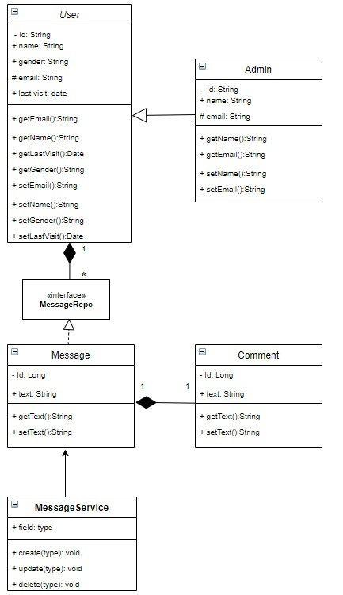

|  |  |  |
| --- | --- | --- |
| **Class name** | **Attributes/Methods** | **Data type/Comment about method assigment** |
| Admin | Id | String |
|  | name | String |
|  | Email | String |
|  | Method1: getName | This method return admin’s Name from database. |
|  | Method2: setName | This method record admin’s name in database |
|  | Method3: getEmail | This method return admin’s Email from database. |
|  | Method4: setEmal | This method record admin’s email in database |
| User | Id | String |
|  | name | String |
|  | Email | String |
|  | Gender | String |
|  | Last visit | Date |
|  | Method1: getName | This method return user’s Name from database. |
|  | Method2: setName | This method record user’s name in database |
|  | Method3: getEmail | This method return user’s Email from database. |
|  | Method4 setEmal | This method record user’s email in database |
|  | Method5: getGender | This method return user’s gender from database. |
|  | Method6: setGender | This method record user’s gender in database |
|  | Method7: geLastVisit | This method return user’s last visit from database. |
|  | Method8: setLastVisit | This method record user’s last visit in database |
| Class “Interface” MessageRepo |  | Message’s repository |
| Message | Id | Long |
|  | Text | String |
|  | Method1: getText | This method return message’s Text from database. |
|  | Method2: setText | This method record message’s Text in database |
| Comment | Id | Long |
|  | Text | String |
|  | Method1: getText | This method return comment’s Text from database. |
|  | Method2: setText | This method record comment’s Text in database |
| MessageService | field | type |
|  | Method1: Create | This method create message. |
|  | Method2: Update | This method update message |
|  | Method2: Delete | This method delete message |

**Sequence diagram**

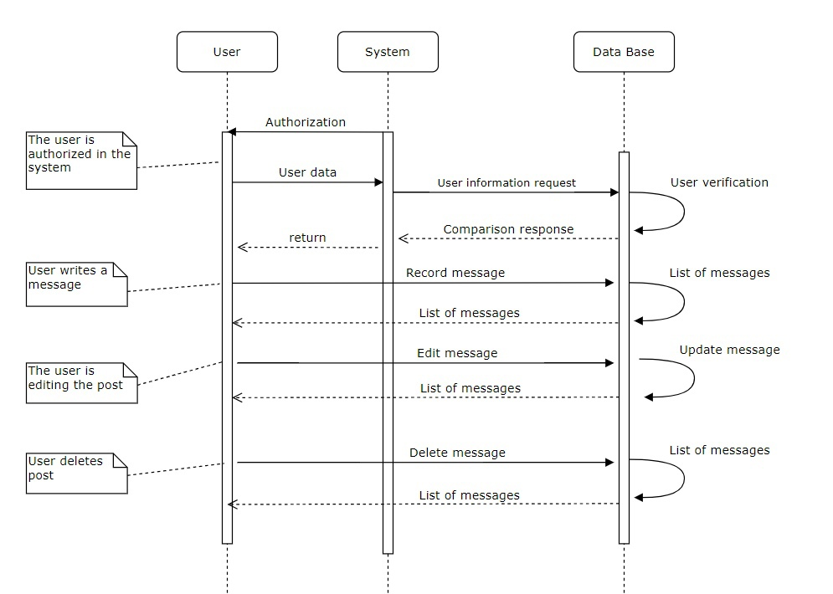

**Conclusion**

In the course of the work, the skills of constructing Class and Sequence diagrams were acquired. The main methods for designing this type of diagrams were studied.